–

# Eproject 2025

|  |  |  |  |
| --- | --- | --- | --- |
| **Supervisor** | | Sir Mouaviz | |
| **Batch** | | 2301B | |
| **Project Name** | | Hotel Management System | |
| **Serial No.** | **Enrollment Number** | | **Student Name** |
| 1. | Student1413911 | | SYED KASHAN ABBAS NAQVI |
| 2. | Student1415086 | | MUHAMMAD ANAS |
| 3. | Student1448007 | | BHARTI |
| 4 | Student1415051 | | AYESHA FAROOQI |
| 5. | Student1445801 | | SYEDA ZOHRA SHAH |

1

**Hotel Management System**

## Table of Contents

1. 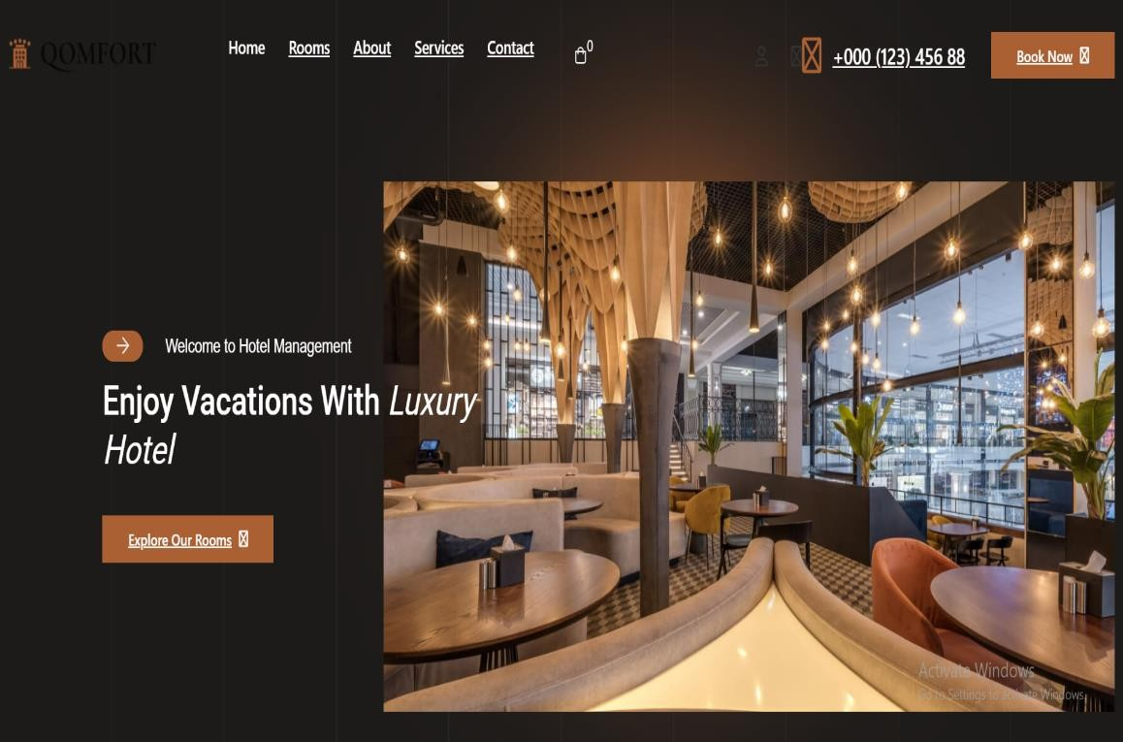Introduction
2. Functional

Requirements

1. Non-Functional Requirements
2. User Guide
3. Hardware-Software Requirement
4. System Architecture
5. Troubleshooting
6. Conclusion

## Introduction

The Hotel Management System is a comprehensive solution designed to streamline hotel

operations, enhance guest experience, and optimize workflows. This website provides hotel management systems to handle reservations User Management: Admin Dashboard, Staff Profiles, Guest Profiles, Room Management: Room Inventory, Room Booking, Room Status Updates, Reservation and Check-in/out: Reservation System, Check-in/Check-out, Billing and Invoicing: Billing System, Invoicing, Housekeeping and Maintenance: Housekeeping

Management, Maintenance Requests, Reporting and Analytics: Reporting Dashboard, Analytics, Security and Compliance: User Authentication, Feedback and Guest Services:

Feedback Mechanism, Additional Services, System Administration: System Settings, System Notifications and more, all in one platform.

2

### Functional Requirements

#### User Management:

Admin Dashboard: An admin panel to manage user roles and permissions.

Staff Profiles: Ability to create, modify, and deactivate staff accounts with different access levels (manager, receptionist, housekeeping, etc.).

Guest Profiles: Creation and management of guest profiles with details like personal information, contact, preferences, etc.

#### Room Management:

Room Inventory: Maintain a comprehensive inventory of rooms with details on room types, availability, status (cleaning, occupied, available), and pricing.

Room Booking: Allow staff to reserve rooms, check availability, assign rooms to guests, and manage bookings efficiently.

Room Status Updates: Enable real-time updates on room status (cleaning, maintenance, vacant, occupied) for better coordination among staff.

#### Reservation and Check-in/out:

Reservation System: Facilitate booking management, allowing guests to make reservations online or through staff, providing confirmation details.

Check-in/Check-out: Smooth check-in and check-out processes with automated procedures for room allocation, key issuance, billing, and updating room status. Billing and Invoicing:

Billing System: Generate accurate bills based on room rates, additional services (food, laundry, etc.), and duration of stay.

Invoicing: Provide guests with detailed invoices that can be printed or emailed, including breakdowns of charges.

#### Housekeeping and Maintenance:

Housekeeping Management: Allow housekeeping staff to view room status, schedule cleaning tasks, mark tasks as completed, and report maintenance issues.

Maintenance Requests: Enable guests or staff to report maintenance issues and track their resolution status.

#### Reporting and Analytics:

Reporting Dashboard: Provide management with insights via customizable reports on occupancy rates, revenue, guest feedback, etc.

Analytics: Utilize data analytics to forecast demand, optimize pricing, and improve service

3

offerings.

#### Security and Compliance:

User Authentication: Implement secure login/logout mechanisms for staff and guests with role-based access control.

#### Feedback and Guest Services:

Feedback Mechanism: Provide a way for guests to leave feedback and ratings, helping in improving services.

Additional Services: Allow guests to request additional services like room service, wake-up calls, transportation, etc.

#### System Administration:

System Settings: Admin controls for system configurations, including setting room rates, defining policies, managing taxes, etc.

System Notifications: Alerts and notifications for staff regarding bookings, maintenance requests, and other critical updates.

### Non-Functional Requirements

#### Performance:

Response Time: The application should respond to user interactions within 1-2 seconds for most operations.

Scalability: The system should be able to handle a growing number of users and data without significant performance degradation.

Concurrent Users: The application should support hundreds of concurrent users without performance bottlenecks.

#### Security:

Data Encryption: All sensitive user data, including passwords and personal information, must be securely encrypted during storage and transmission.

Authentication: User authentication should be secure and use industry-standard practices to prevent unauthorized access.

Authorization: Access control must be implemented to ensure users can only access their own data or public data, as per their settings.

#### Privacy:

Data Privacy: The application must comply with data privacy regulations such as GDPR, ensuring user data is handled and stored with care.

User Consent: Users should have control over the data they share and provide informed

4

consent for data processing and sharing.

#### Reliability:

Uptime: The application should aim for a minimum of 99% uptime, with scheduled maintenance communicated in advance.

Data Backup: Regular automated data backups must be performed to prevent data loss in case of system failures.

#### Usability:

User Interface Design: The application should have an intuitive, user-friendly interface with consistent navigation and a responsive design that works on various devices.

Accessibility: The application must adhere to accessibility standards (e.g., WCAG) to ensure it is usable by individuals with disabilities.

#### Compatibility:

Cross-Browser Compatibility: The application should function correctly on popular web browsers, including Chrome, Firefox, Safari, and Edge.

Mobile Compatibility: The application should be responsive and work well on various mobile devices and screen sizes.

#### Scalability:

Horizontal Scalability: The architecture should support horizontal scaling to accommodate increased user loads as the user base grows.

#### Performance Monitoring:

Logging and Monitoring: The system should include logging and monitoring tools to track application performance, errors, and user activity for debugging and analysis.

#### Testing and Quality Assurance:

Test Coverage: A comprehensive test suite should be maintained, covering unit testing, integration testing, and end-to-end testing.

Security Testing: Regular security assessments, including penetration testing, must be conducted to identify vulnerabilities.

5

### User Guide

#### For Guests:

* + Booking a Room:

1. Visit the website and navigate to the booking page.
2. Select the check-in and check-out dates.
3. Choose the room type and proceed to the booking form.
4. Enter personal details and payment information.
5. Confirm the reservation.
   * Managing Reservations:
6. Log into your account using your credentials.
7. Go to the "My Bookings" section.
8. View, modify, or cancel your reservations.
   * Check-in/Check-out:
9. On the check-in day, visit the front desk or use the online check-in feature.
10. Receive room key or digital access.
11. Upon check-out, review your bill and make payments.

#### For Admins:

* + Managing Users:

1. Log into the Admin Dashboard.
2. Create or manage user accounts (staff or guests).
3. Assign roles and manage permissions.
   * Room Management:
4. Add new rooms and set pricing.
5. Update room availability and status (e.g., occupied, under maintenance).
6. View room reservation history.

### Hardware and software requirements

#### Hardware Requirements:

1. A minimum computer system that will help you access all the tools in the courses is a Pentium 166 or better
2. 128 Megabytes of RAM or better
3. Windows 2000 Server (or higher if possible)

#### Software Requirements:

6

Use software as per your requirement

1. Windows OS /MongoDB/Express/React/Node.js/Notepad

### System Architecture

The Hotel Management Website follows a client-server architecture, where:

* + Frontend: Built using React.js, providing an interactive, responsive, and dynamic user interface.
  + Backend: The server-side logic is handled by Node.js and Express.js.
  + Database: Data storage is handled using MongoDB, which stores information about rooms, guests, bookings, etc.
  + Authentication: Users authenticate using JWT tokens for secure login/logout procedures.
  + Web Browser: Google Chrome, Mozilla Firefox, Safari, or Edge.
  + Code Editor: Visual Studio Code.

### Troubleshooting

#### Common Issues and Solutions:

* + Issue: Guests unable to make reservations.

Solution: Ensure the booking system is not overbooked. Check room availability and confirm payment gateway functionality.

* + Issue: Admin unable to access the dashboard.

Solution: Verify the admin credentials and ensure the admin role has the necessary permissions.

### Conclusion

This Hotel Management System Website is designed to enhance the efficiency of hotel operations and provide a seamless experience for both guests and hotel staff. With a user- friendly interface and robust features, it will ensure smooth management of reservations, room assignments, billing, and other essential hotel functions.

7

## USER VIEW

1. Log in / Log out
2. Sign up
3. Otp
4. Room grid
5. Room Details
6. View profile
7. Edit profile
8. Contact us
9. View bookings & Handle bookings
10. Services / Reviews

**1.LOG IN 2.SIGN UP**

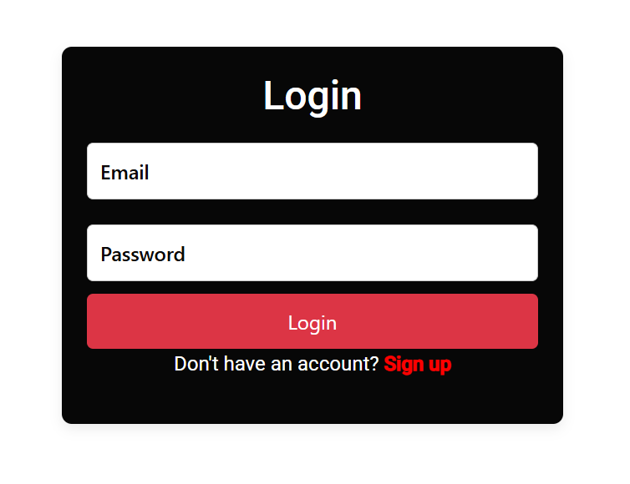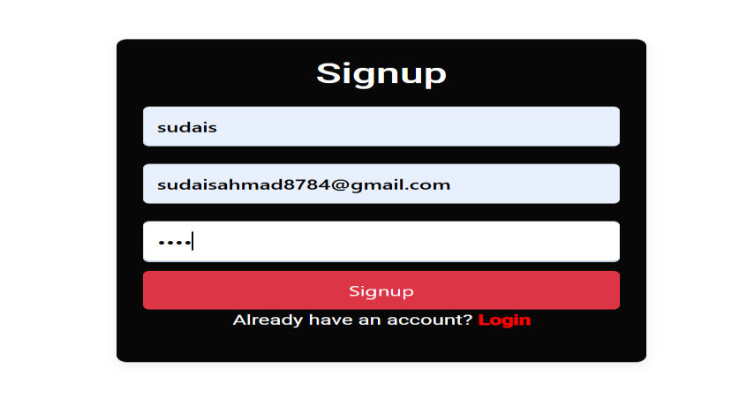

**3.OTP 4.ROOM GRID**

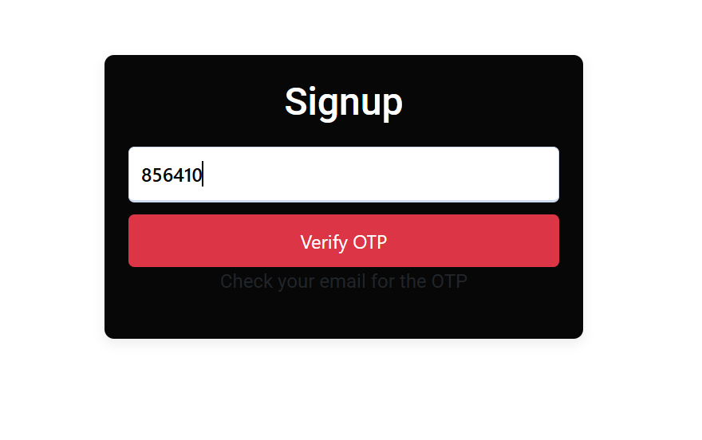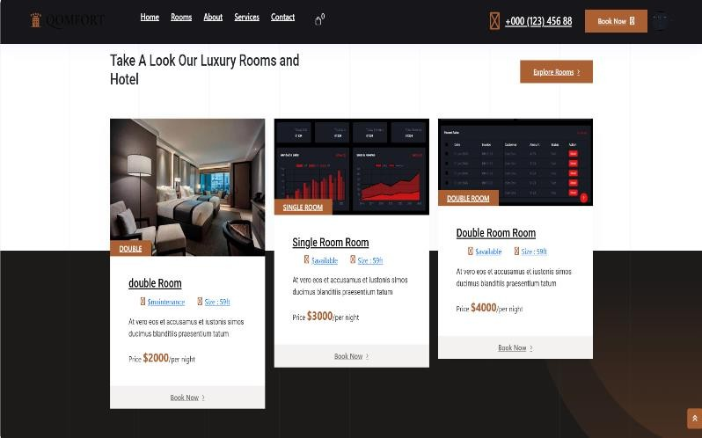

8

1. **ROOM DETAILS / BOOKING**
2. **IEW PROFILE**

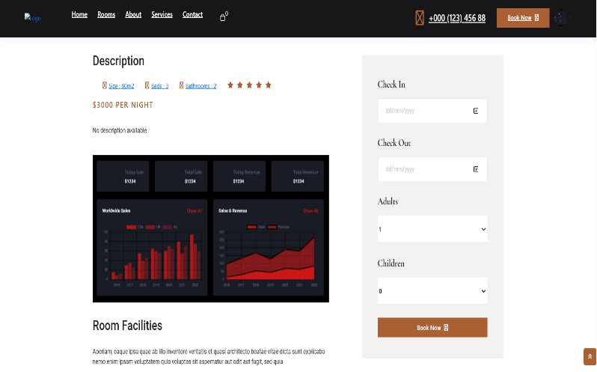 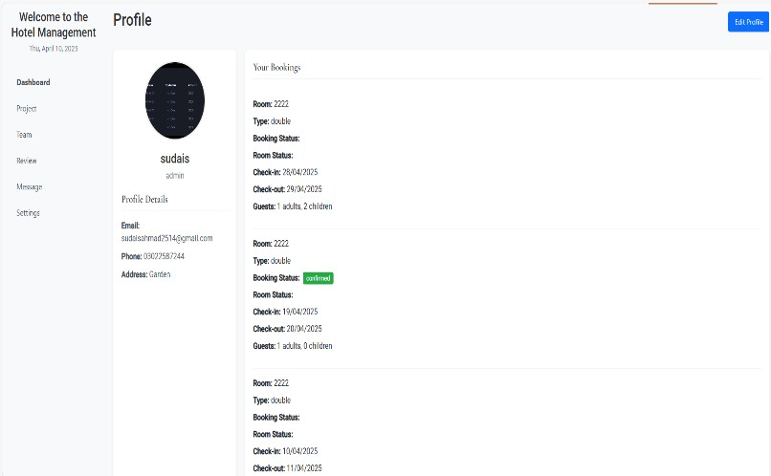

1. **EDIT PROFILE 8.CONTACT US**

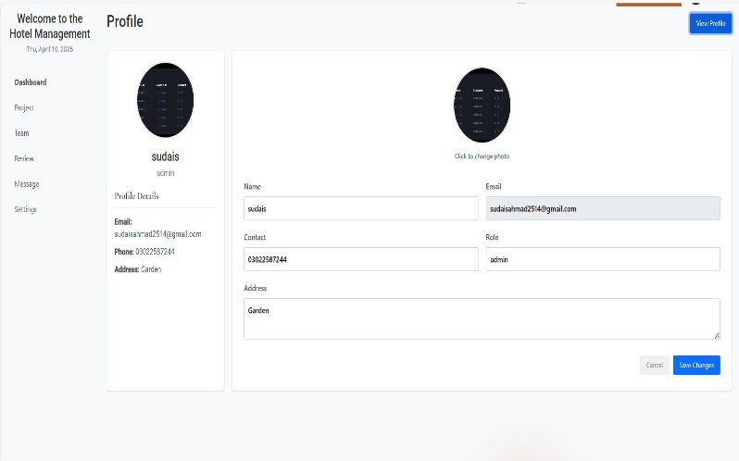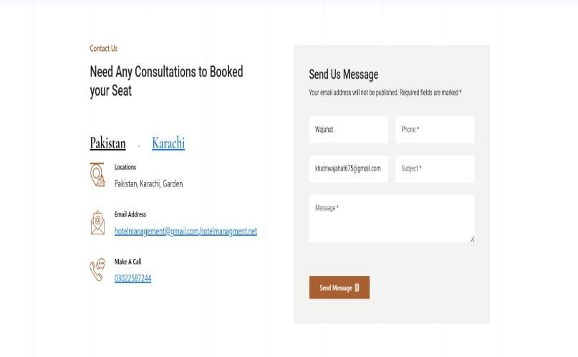

1. 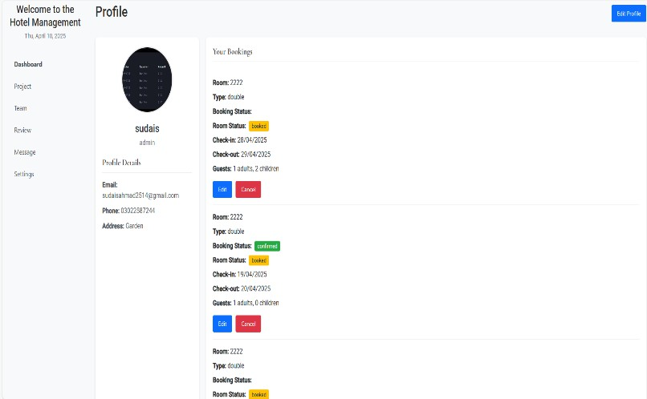**IEW BOOKINGS & HANDLE BOOKINGS**

9

1. **SERVICES / REVIEWS**

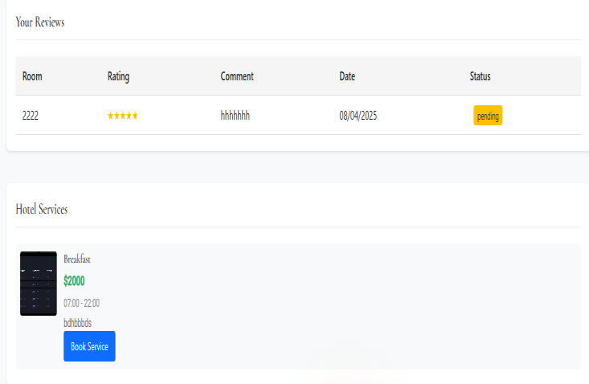

## ADMIN PANEL

1. User Management
2. Room Management 3.Reservation System
3. Handle User Booking
4. Handle Checked In User
5. Handle Checked out User
6. Handle Services
7. View Guest Reviews
8. Handle Issues
9. Reports
10. View Feedbacks
11. **USER MANAGEMENT**



10

1. **ROOM MANAGEMENT**

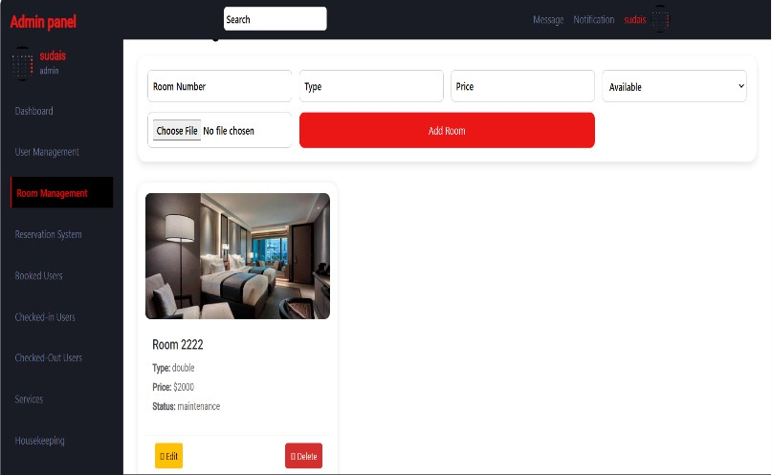

1. **RESERVATION SYSTEM 4.HANDLE USER BOOKING**

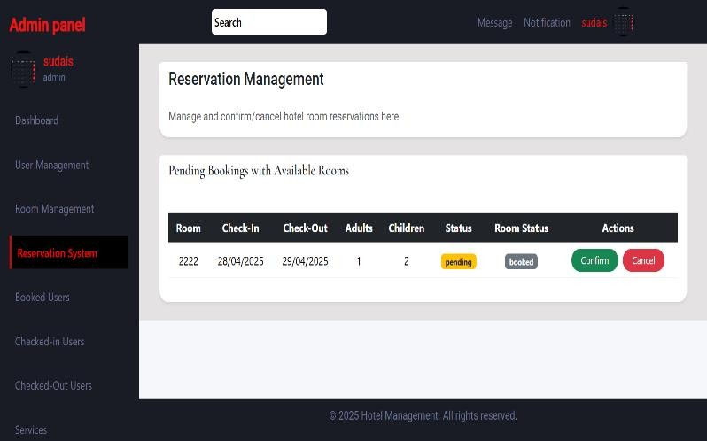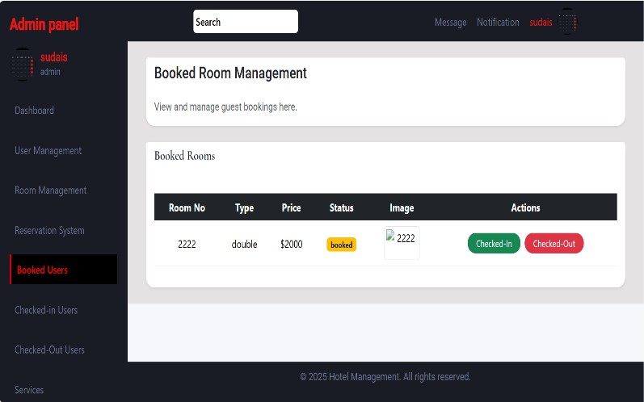

1. **HANDLE CHECKED IN USER 6.HANDLE CHECKED OUT**

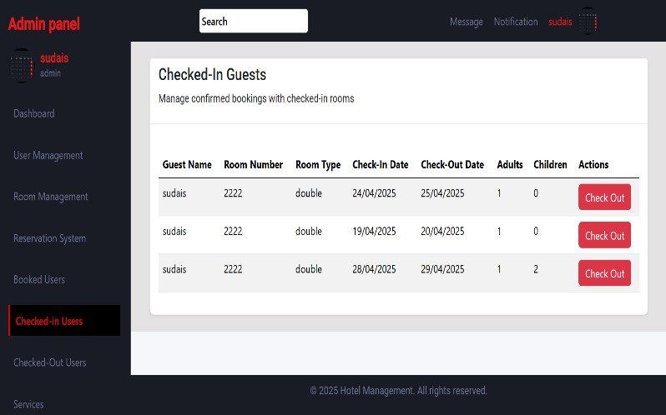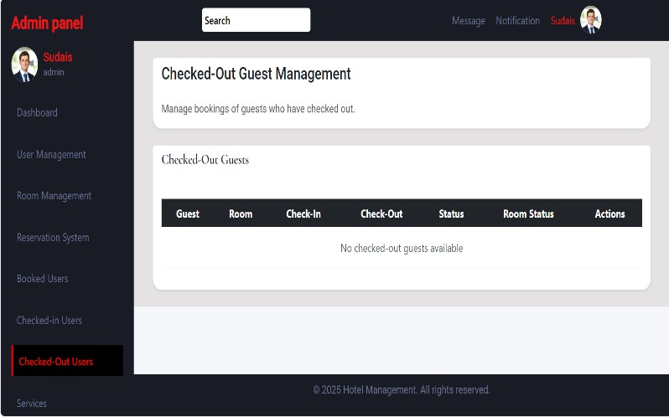

**7.HANDLE SERVICES 8.VIEW GUEST REVIEWS**

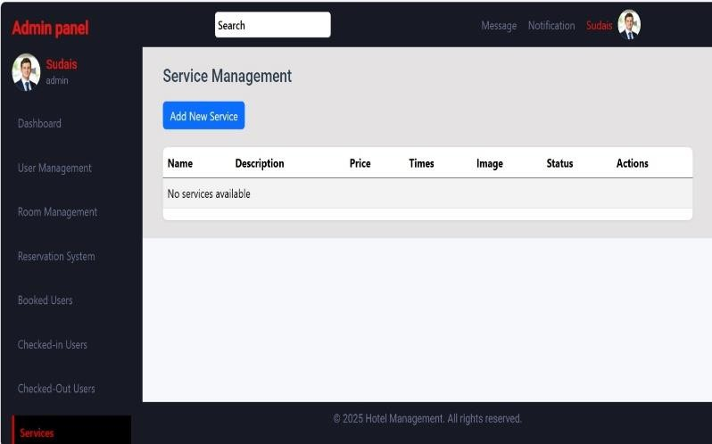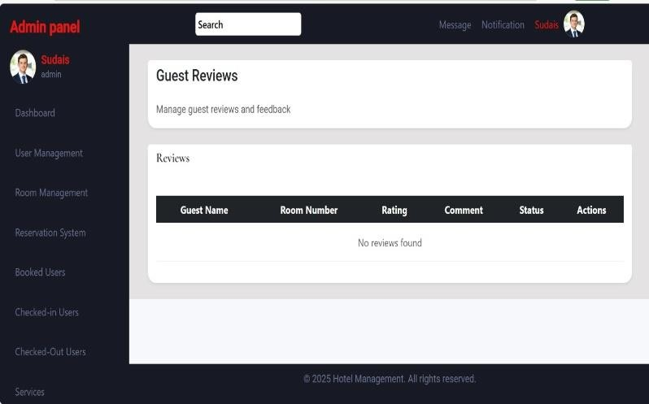

11

1. **HANDLE ISSUES**
2. **REPORTS**

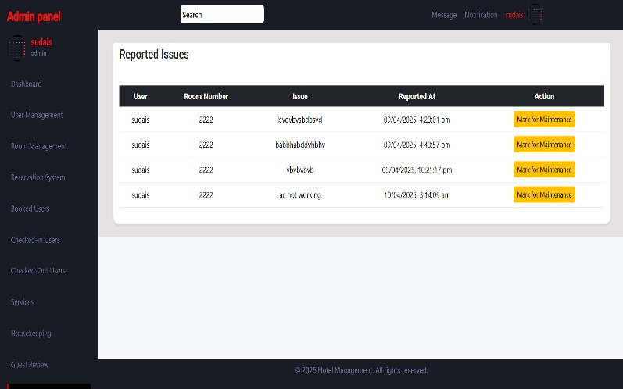 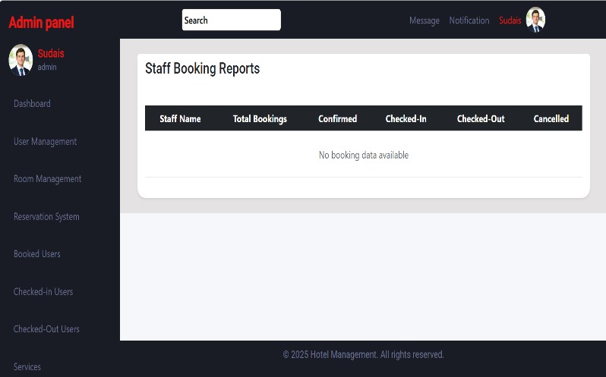

1. **IEW FEEDBACK**

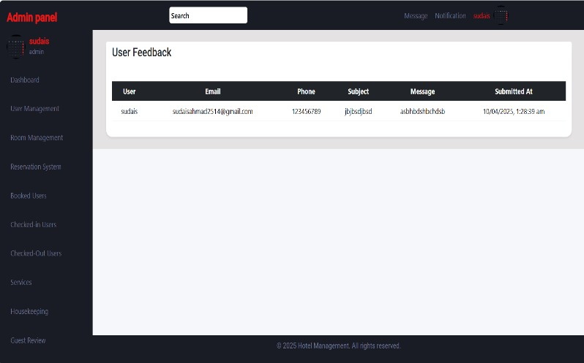

12

## HOTEL STAFF

* 1. Reservation System
  2. Handle User Booking
  3. Handle Checked In User
  4. Handle Checked out User
  5. House Keeping
  6. Room Maintenance 7.Reporting Issue

8.Service Request

**1.RESERVATION SYSTEM 2.HANDLE USER BOOKING**

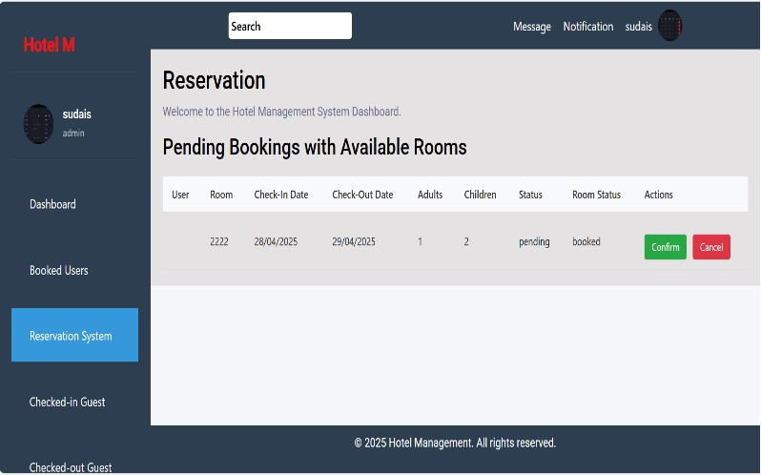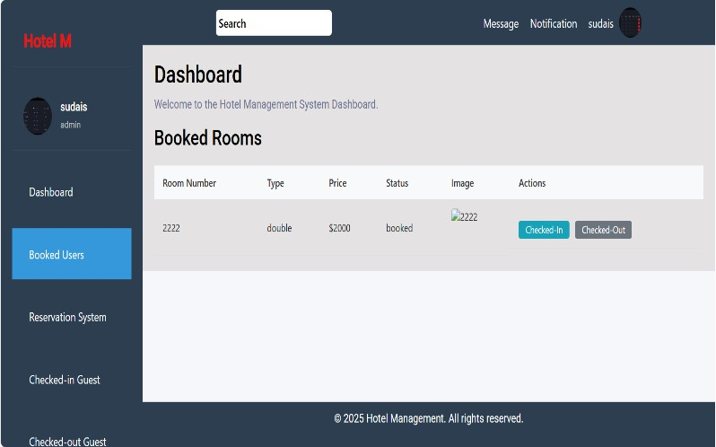

13

1. **HANDLE CHECKED IN**

**USER**

1. **HOUSE KEEPING**
2. **HANDLE CHECKED OUT**

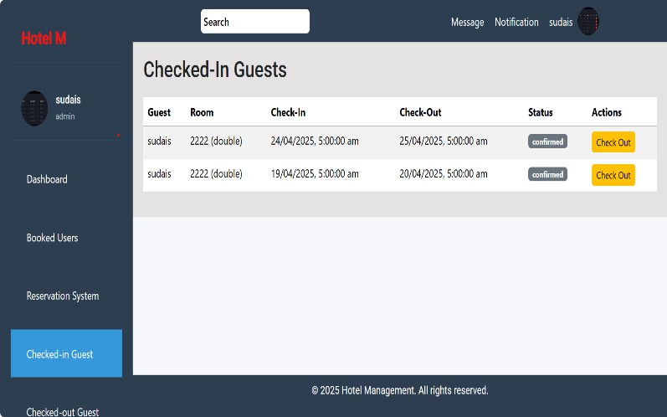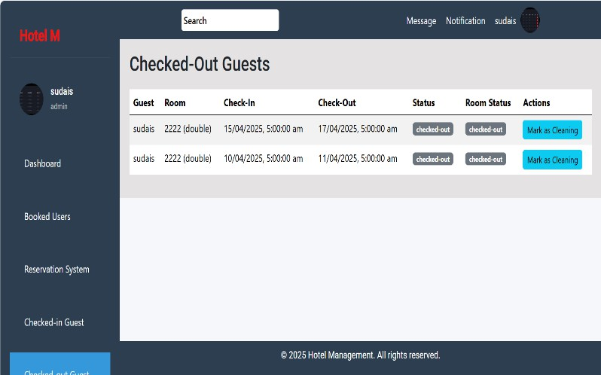**USER**

1. **ROOM MAINTENANCE**

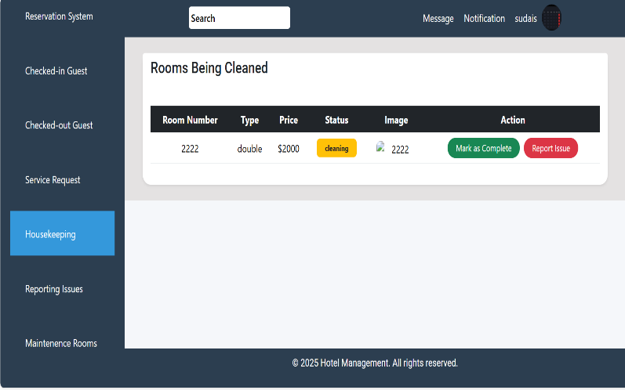 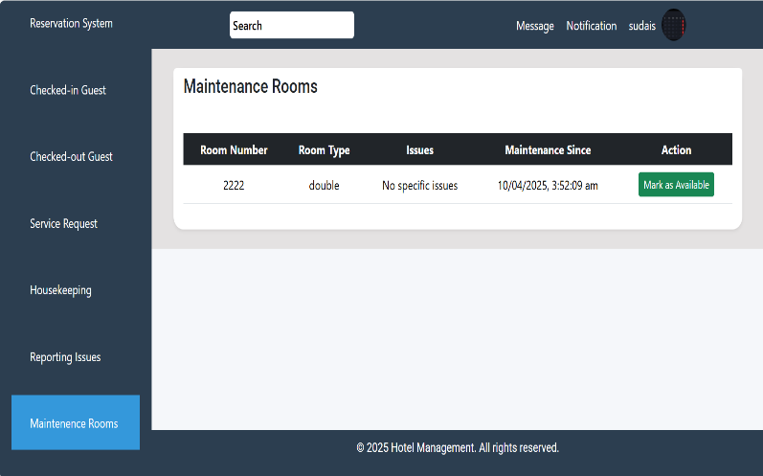

1. **REPORTING ISSUE 8.SERVICE REQUEST**

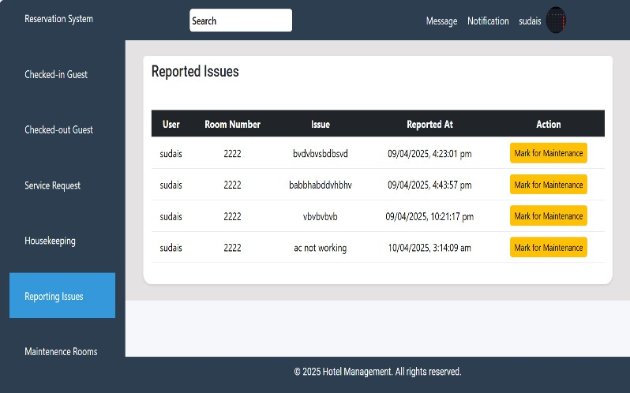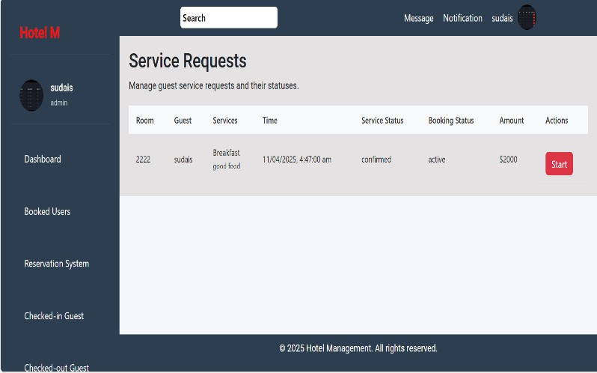

14

**PACKAGES**

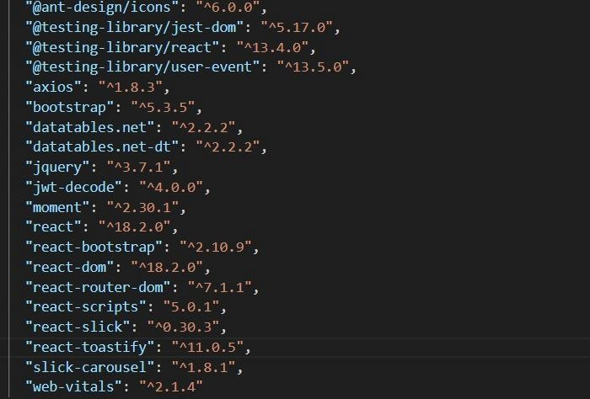

# THANK YOU

15

16